**// JAVA WITH SERVLET REGISTATION FROM TASK //**

**// USERFORM.HTML**

<html>

<head>

<meta charset="UTF-8">

<meta name="viewport" content="width=device-width, initial-scale=1.0">

<title>Registration Form</title>

</head>

<body>

<h1>Registration form</h1>

<form action="RF">

Enter Your FirstName : <input type="text" name="name"><br><br>

Enter your last name : <input type="text" name="lastname"><br><br>

Enter your password : <input type="password" name="password"><br><br>

ReEnter your password : <input type="password" name="repassword"><br><br>

Enter your email : <input type="email" name="email"><br><br>

Enter your mobile : <input type="text" name="mobile"><br><br>

Enter your address : <input type="text" name="address"><br><br>

Select your gender :

<input type="radio" name="gender" value="male"> Male

<input type="radio" name="gender" value="female"> Female

<input type="radio" name="gender" value="other"> Other<br><br>

Select sports you love :

<input type="checkbox" name="sports" value="cricket"> cricket

<input type="checkbox" name="sports" value="football"> football

<input type="checkbox" name="sports" value="hockey"> hockey<br><br>

Select your Date of Birth : <input type="date" name="dob"><br><br>

Select your country :

<select name="country">

<option>... Select your country...</option>

</select><br><br>

<input type="submit" value="REGISTER">

<input type="reset" value="RESET">

</form>

</body>

</html>

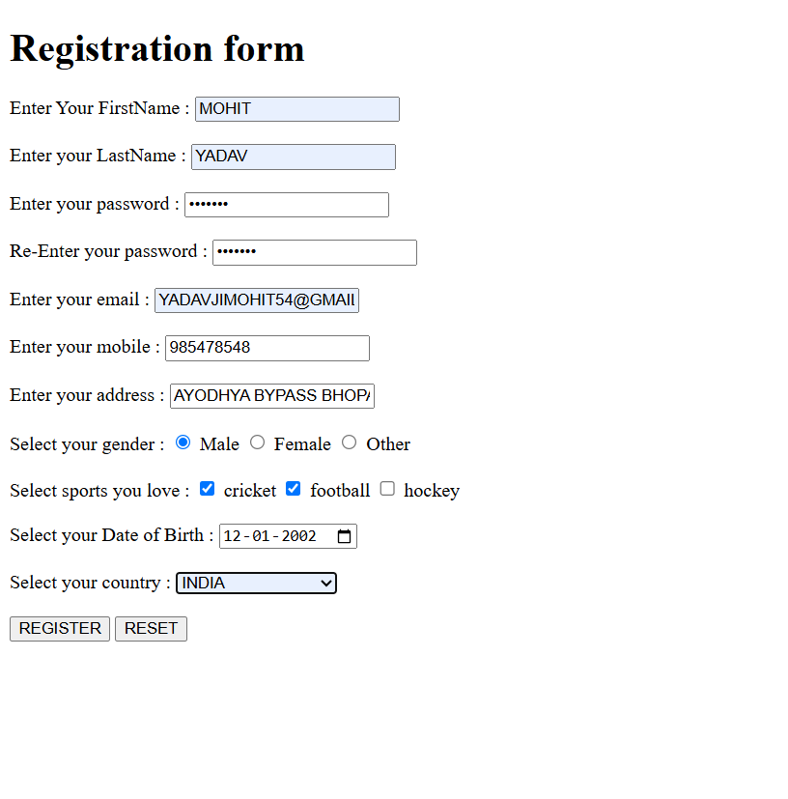

**// USER.SERVLET**

**/\***

**\* To change this license header, choose License Headers in Project Properties.**

**\* To change this template file, choose Tools | Templates**

**\* and open the template in the editor.**

**\*/**

**import java.io.IOException;**

**import java.io.PrintWriter;**

**import javax.servlet.ServletException;**

**import javax.servlet.http.HttpServlet;**

**import javax.servlet.http.HttpServletRequest;**

**import javax.servlet.http.HttpServletResponse;**

**/\*\***

**\***

**\* @author yadav**

**\*/**

**public class user extends HttpServlet {**

**/\*\***

**\* Processes requests for both HTTP <code>GET</code> and <code>POST</code>**

**\* methods.**

**\***

**\* @param request servlet request**

**\* @param response servlet response**

**\* @throws ServletException if a servlet-specific error occurs**

**\* @throws IOException if an I/O error occurs**

**\*/**

**protected void processRequest(HttpServletRequest request, HttpServletResponse response)**

**throws ServletException, IOException {**

**response.setContentType("text/html;charset=UTF-8");**

**try (PrintWriter out = response.getWriter()) {**

**/* TODO output your page here. You may use following sample code. */**

**out.println("<!DOCTYPE html>");**

**out.println("<html>");**

**out.println("<head>");**

**out.println("<title>Servlet user</title>");**

**out.println("</head>");**

**out.println("<body>");**

**String firstName = request.getParameter("name");**

**String lastName = request.getParameter("lastname");**

**String p = request.getParameter("ps"); // Fixed: Use String for passwords**

**String cp = request.getParameter("reps"); // Fixed: Use String**

**String email = request.getParameter("email");**

**String mobile = request.getParameter("mobile"); // Fixed: Use String for mobile**

**String address = request.getParameter("ad");**

**String gender = request.getParameter("gender");**

**String dob = request.getParameter("dob");**

**String country = request.getParameter("ctr");**

**// Retrieving multiple checkbox values**

**String[] sports = request.getParameterValues("sports");**

**// Displaying the received data**

**out.println("<!DOCTYPE html>");**

**out.println("<html>");**

**out.println("<head>");**

**out.println("<title>Registration Details</title>");**

**out.println("</head>");**

**out.println("<body>");**

**out.println("<h2>Registration Details</h2>");**

**out.println("<p>First Name: " + firstName + "</p>");**

**out.println("<p>Last Name: " + lastName + "</p>");**

**out.println("<p>Password: " + p + "</p>");**

**out.println("<p>ConfirmPassword: " + cp + "</p>");**

**out.println("<p>Email: " + email + "</p>");**

**out.println("<p>Mobile: " + mobile + "</p>");**

**out.println("<p>Address: " + address + "</p>");**

**out.println("<p>Gender: " + gender + "</p>");**

**out.println("<p>Date of Birth: " + dob + "</p>");**

**out.println("<p>Country: " + country + "</p>");**

**// Handling sports selection safely**

**out.print("<p>Sports: ");**

**if (sports != null) {**

**for (String sp : sports) {**

**out.print(sp + " ");**

**}**

**} else {**

**out.print("None");**

**}**

**out.println("</p>");**

**out.println("</body>");**

**out.println("</html>");**

**}**

**}**

**// <editor-fold defaultstate="collapsed" desc="HttpServlet methods. Click on the + sign on the left to edit the code.">**

**/\*\***

**\* Handles the HTTP <code>GET</code> method.**

**\***

**\* @param request servlet request**

**\* @param response servlet response**

**\* @throws ServletException if a servlet-specific error occurs**

**\* @throws IOException if an I/O error occurs**

**\*/**

**@Override**

**protected void doGet(HttpServletRequest request, HttpServletResponse response)**

**throws ServletException, IOException {**

**processRequest(request, response);**

**}**

**/\*\***

**\* Handles the HTTP <code>POST</code> method.**

**\***

**\* @param request servlet request**

**\* @param response servlet response**

**\* @throws ServletException if a servlet-specific error occurs**

**\* @throws IOException if an I/O error occurs**

**\*/**

**@Override**

**protected void doPost(HttpServletRequest request, HttpServletResponse response)**

**throws ServletException, IOException {**

**processRequest(request, response);**

**}**

**/\*\***

**\* Returns a short description of the servlet.**

**\***

**\* @return a String containing servlet description**

**\*/**

**@Override**

**public String getServletInfo() {**

**return "Short description";**

**}// </editor-fold>**

**}**

